Name : Sundara Moorthy
Reg No : 192324228
Course code : Cloud Computing And Big Data Analysis
Exp No : EXPERIMENT 6
Date : 24/12/2025

EXPERIMENT 6
Title
Demonstration of Virtualization by Installing a Type-2 Hypervisor Using VirtualBox

Aim
To demonstrate virtualization by installing a Type-2 Hypervisor (VirtualBox) and creating a virtual machine with a host operating system.

Requirements
- Oracle VirtualBox
- Host Operating System (Windows/Linux)
- Minimum 4GB RAM system
- ISO file of Guest OS

Procedure
- Download Oracle VirtualBox from the official website.
- Install VirtualBox on the host system.
- Launch VirtualBox after installation.
- Verify that VirtualBox runs on top of the existing host OS, confirming it is a Type-2 Hypervisor.

Output
- VirtualBox installed successfully.
- Hypervisor runs on the host operating system.
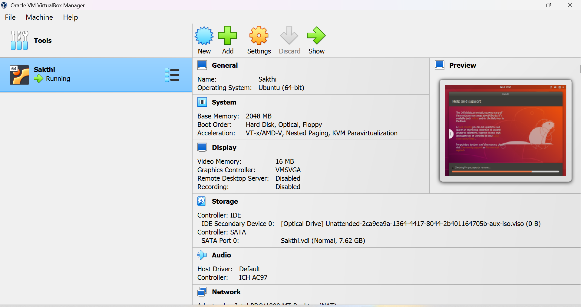

Result
Thus, virtualization was successfully demonstrated by installing a Type-2 Hypervisor (VirtualBox) on the host system.

